Add « Edit profile » feature on Ios & Android native app
through our JSON API

On our Ios & Android native app, if you choose « Profile » menu, you will get this screen (french at left and english at right) :
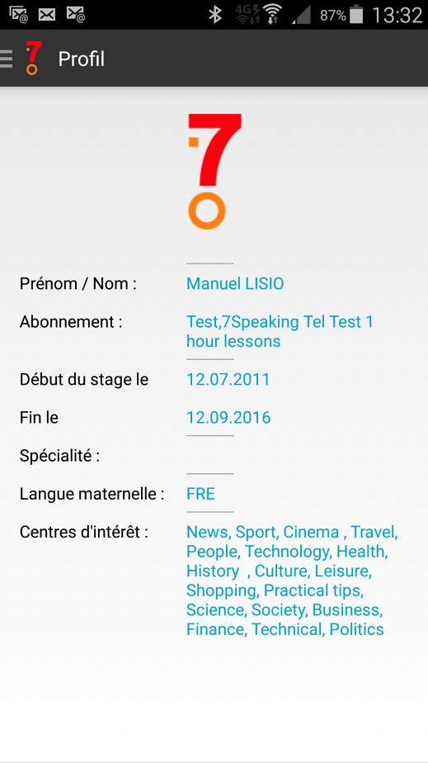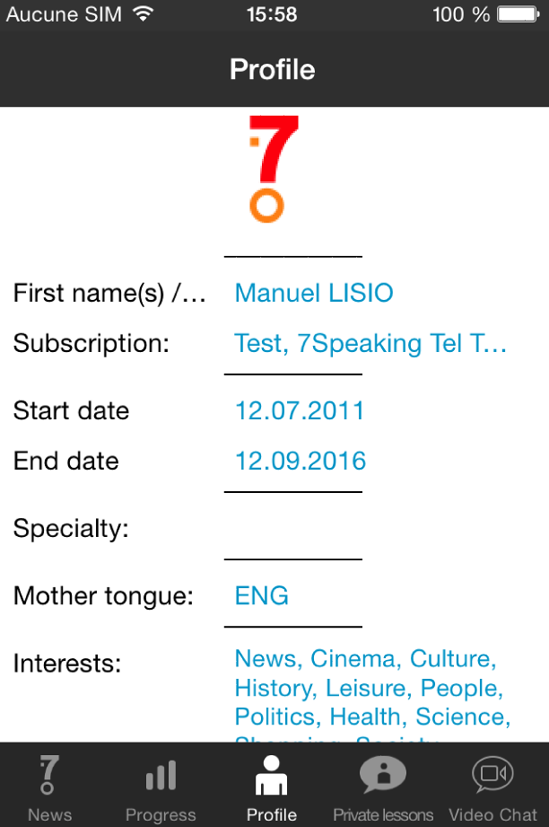

The job consists in :
- Displaying some more information to this screen thanks to our JSON API.
- Adding an « Edit » and « Save » button so that the user could change the values.

- Here below is the screen we will get after your development. The new information are in yellow (the other are already displayed).
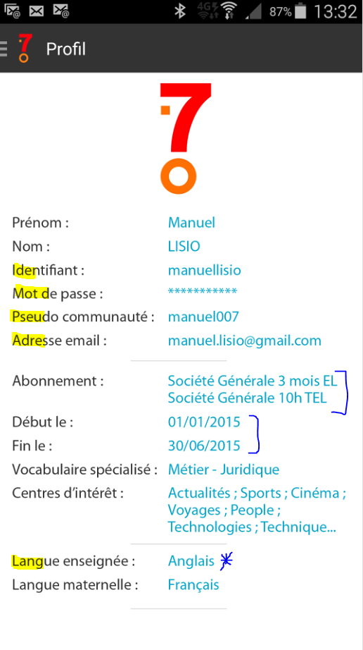
2-You will add an « Edit » button to this screen and if the users chooses it, he will be able to change all the values except the information where there are ] above on the screen.
The information with a * above (Langue enseignée means Language taught) on the screen can be changed depending on the number of values returned by the API (only one in most cases).

Important : all the texts come from the API because all of them are translated into 12 languages on our webserver (depending on the Mother tongue chosen by the user).So don’t use any hardcoded text.


Regarding the 3 fields above (Specialized vocabulary ; Language taught and Mother tongue), in Edit mode, each of them will be a drowndown list and the user will choose only one value in the list.
Remark : as soon as the Mother tongue is changed, the language of all the interface will change.


Regarding the field above, it will be a list of values with checkboxes. Several of them can be checked by the user.

Here is the API :

1. userprofile
This API returns information profile of the user :

http://www.7speaking.com/webservice/api.cfc?wsdl&method=userprofile&userid=35978&sessionid=2e303582cfcfbeb56c7c443fd4828534ef40

{"status":"success","userid":35978.0,"firstname":"Jao","lastname":"nary","login":"upto25","password":"upto25","pseudo":"bajojo","email":"josoarajao@gmail.com","subscriptionid":5271,"subscription":"7Speaking demo signature","startdate":"mai, 03 2012 00:00:00","enddate":"octobre, 15 2015 00:00:00","specialtyid":31,"specialty":"Meetings","interests":[{"interestid":1,"interest":"Actualités"},{"interestid":3,"interest":"Cinéma"},{"interestid":10,"interest":"Culture"},{"interestid":9,"interest":"Histoire"},{"interestid":11,"interest":"Loisirs"},{"interestid":6,"interest":"People"},{"interestid":141,"interest":"Politique"},{"interestid":5544,"interest":"Professional Skills"},{"interestid":8,"interest":"Santé"},{"interestid":14,"interest":"Sciences"},{"interestid":12,"interest":"Shopping"},{"interestid":16,"interest":"Société"},{"interestid":2,"interest":"Sports"},{"interestid":7,"interest":"Technologies"},{"interestid":13,"interest":"Vie pratique"},{"interestid":4,"interest":"Voyages"}],"languagetaught":[{"code":"ENG","lib":"ENG"},{"code":"SPA","lib":"SPA"}],"mothertongue":"FRE"}

2. setuserprofile
This API permits to update the information profile of the user and includes required controls.

http://www.7speaking..com/webservice/api.cfc?wsdl&method=setuserprofile&userid=35978&sessionid=2e303582cfcfbeb56c7c443fd4828534ef40&userinfo={"firstname":"Jao", "lastname":"nary", "login":"upto2515", "password":"upto2515", "pseudo":"eleo1x"}

And the server will reply this :
{"status":"success","userid":35978.0,"message":""}

getmothertonguelist : returns the list of mother tongues

Remark : list of language taught are inside API userprofile

getspecialitylist : returns the list of « Vocabulaire spécialisé » (Specialized Vocabulary)

getinterestlist : returns the list of centers of intérests.

If you need to see the translation of an existing text you can use this example :
Into english (mothertongue=ENG):
http://www.7speaking.com/webservice/api.cfc?wsdl&method=gettranslation&mothertongue=ENG&varname=interface.langue_maternelle
or into french (mothertongue=FRE):
http://www.7speaking.com/webservice/api.cfc?wsdl&method=gettranslation&mothertongue=ENG&varname=interface.langue_maternelle

List of all the text used by the application :
http://www.7speaking.com/webservice/api.cfc?wsdl&method=gettranslation&mothertongue=FRE&varname=all

Examples :

getspecialitylist :
http://www.7speaking.com/webservice/api.cfc?wsdl&method=getspecialitylist

{"specialty":[{"specialtyid":50,"specialty":"Accounting"},{"specialtyid":56,"specialty":"Advertising"},{"specialtyid":55,"specialty":"After Sales Service"},{"specialtyid":43,"specialty":"Banking"},{"specialtyid":34,"specialty":"Business Etiquette"},{"specialtyid":49,"specialty":"Business Trip"},{"specialtyid":59,"specialty":"Communication"},{"specialtyid":52,"specialty":"Computing"},{"specialtyid":41,"specialty":"E-Commerce"},{"specialtyid":42,"specialty":"Finance"},{"specialtyid":61,"specialty":"Food & Beverage"},{"specialtyid":39,"specialty":"Foreign Trade"},{"specialtyid":38,"specialty":"Home Trade"},{"specialtyid":45,"specialty":"Hotel & Restaurant "},{"specialtyid":40,"specialty":"Human Resources - Training"},{"specialtyid":44,"specialty":"Insurance"},{"specialtyid":36,"specialty":"Language Skills"},{"specialtyid":51,"specialty":"Law & Justice"},{"specialtyid":64,"specialty":"Logistics"},{"specialtyid":58,"specialty":"Marketing"},{"specialtyid":57,"specialty":"Media"},{"specialtyid":31,"specialty":"Meetings"},{"specialtyid":33,"specialty":"Negotiating"},{"specialtyid":27,"specialty":"Pharmaceutical industry "},{"specialtyid":35,"specialty":"Presentations"},{"specialtyid":28,"specialty":"Purchasing department"},{"specialtyid":46,"specialty":"Quality Management"},{"specialtyid":47,"specialty":"Secretarial work"},{"specialtyid":53,"specialty":"Telecommunications"},{"specialtyid":30,"specialty":"Telephoning"},{"specialtyid":19,"specialty":"TOEIC Simulation"},{"specialtyid":48,"specialty":"Tourism Industry"},{"specialtyid":29,"specialty":"Writing letters & emails"}]}

getinterestlist:
http://www.7speaking.com/webservice/api.cfc?wsdl&method=getinterestlist

{"interests":[{"interestid":1,"interest":"News"},{"interestid":2,"interest":"Sport"},{"interestid":3,"interest":"Cinema "},{"interestid":4,"interest":"Travel"},{"interestid":6,"interest":"People"},{"interestid":7,"interest":"Technology"},{"interestid":8,"interest":"Health"},{"interestid":9,"interest":"History "},{"interestid":10,"interest":"Culture"},{"interestid":11,"interest":"Leisure"},{"interestid":12,"interest":"Shopping"},{"interestid":13,"interest":"Practical tips"},{"interestid":14,"interest":"Science"},{"interestid":16,"interest":"Society"},{"interestid":141,"interest":"Politics"}]}

